6TH SEPTEMBER 2021: JAILED AND BAILED – RAISING MONEY FOR THE RED CROSS

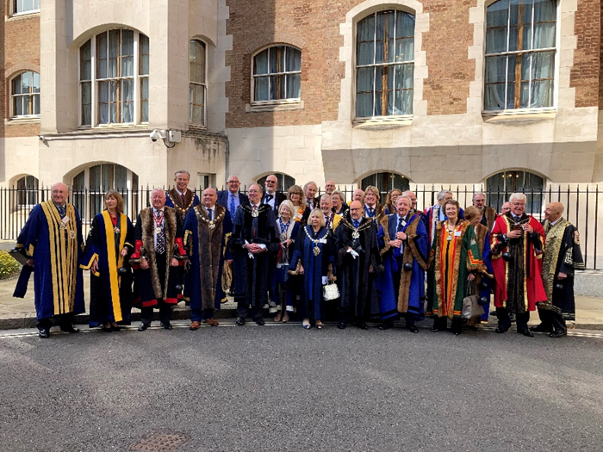

On 6th September 2021 the Master together with other Livery Company Masters appeared at the Central Criminal Court at a jolly ceremony to answer various “charges”, and thence to be transported in chains to the Tower of London where release depended on the payment of “Bail” money.
All in a good cause, of course: the Red Cross.
Thank you very much to all of you who donated the “Bail”, allowing the Master to leave the Tower unscathed, but also providing much-needed funding for which the Red Cross are most grateful.
Margaret raised just under 200% of her required total – a triumph for all.
Pictured (above) with her fellow-felons, and the Sheriffs of the City of London, outside the Central Criminal Court she awaits transport by London Bus to the Tower; and (below) is led through the gates.
