REPORT FROM MAJOR KAZ LORIMER
OFFICER COMMANDING, 13 COMPANY | SW LONDON ACF

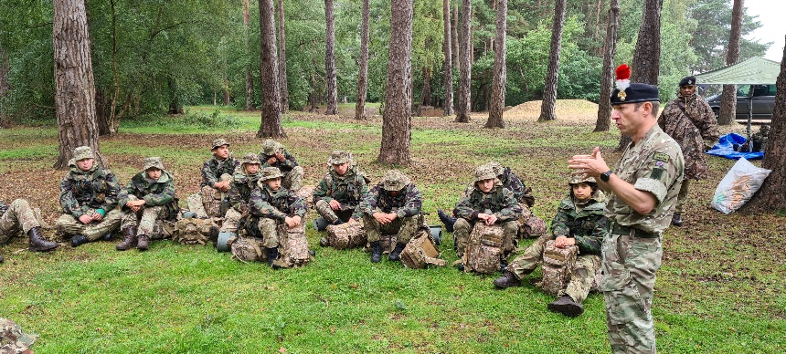

REPORT ON ANNUAL CAMP 12TH AUGUST 2021

Yesterday, 13 Company finished our Annual Camp. While pre-Covid this would mean that we would have gone off to a transit army camp somewhere in the UK, this year it meant staying local and using our HQ locations and some of our satellite locations such as Morden, Battersea and Balham.
The cadets enjoyed activities such as abseiling and caving (using mobile units) laser tag and archery. The cadets also completed some of the more mandatory APC "Green" training. Some of our NCOs also completed their Junior Cadet Instructors Cadre (JCIC) which means that after completion they can support their detachment Commanders in the instructional side of detachment life. The cadets also experienced 24 hours on a field training exercise and a day on the ranges shooting the cadet GP rifle.
While we were in the field we were lucky to host Colonel Chris Head from the First Fusiliers.
Our final parade saw a number of cadets receiving promotions and star level completion badges, Jack Petchey certificates and coins for both Adults and cadets.

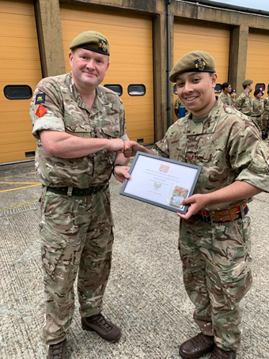
FUTURE PLANS FOR 2021
We will return back from Summer Shutdown in the first week of September. All dependent on COVID-19 restrictions, we have a weekend camp in October, from the 15th to 17th.
Efforts are being made to book some of the instructors from 13 Coy on to an archery instructors course in the autumn: though we have the kit, I am the only currently qualified person.

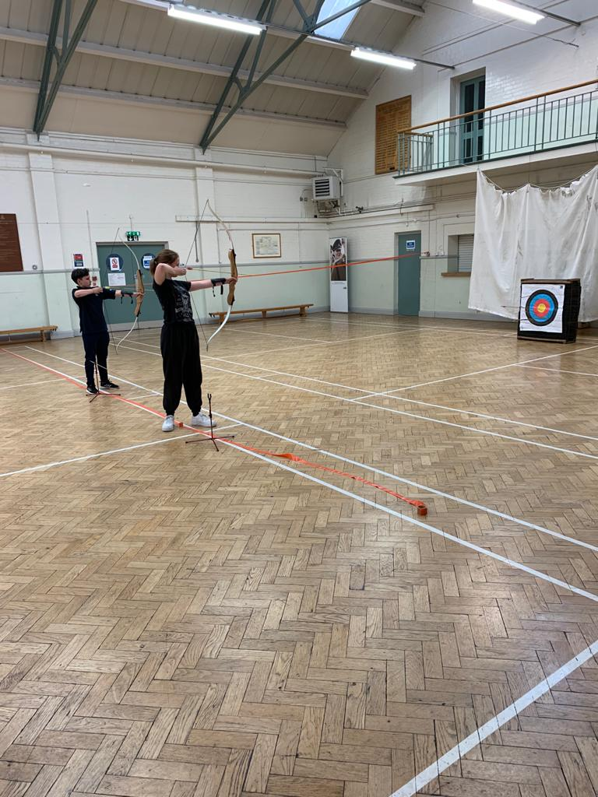
We are planning to attend the Fusilier Remembrances Parade at Holborn and are available to support the Livery Company in the Lord Mayors Show.
Our Christmas Camp this year is being held at Lydd on the weekend of December 3rd to 5th.

MAJOR KAZ LORIMER

